This page contains instructions only, please delete prior to issuing your spec.

1. As is the case with many specifications, you will need to edit this document as appropriate for your project.
2. We have included “**hidden**” instructional text, which is formatted as ORANGE, ALL CAPS
3. Go to **File**/**Options**/**Display** and make sure “**hidden** **text**” has a checkmark (so that it appears in this template), and “**print** **hidden** **text**” does not have a checkmark.

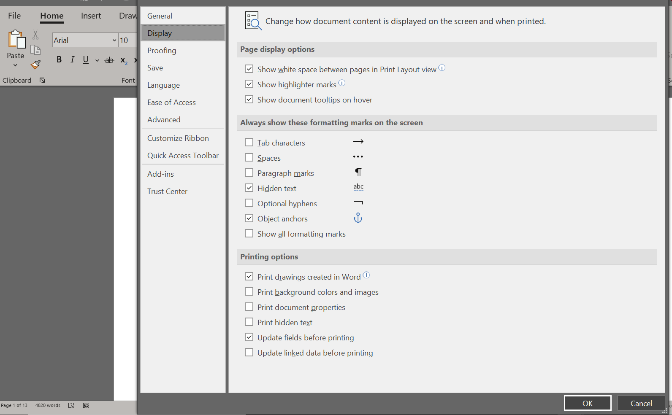

1. 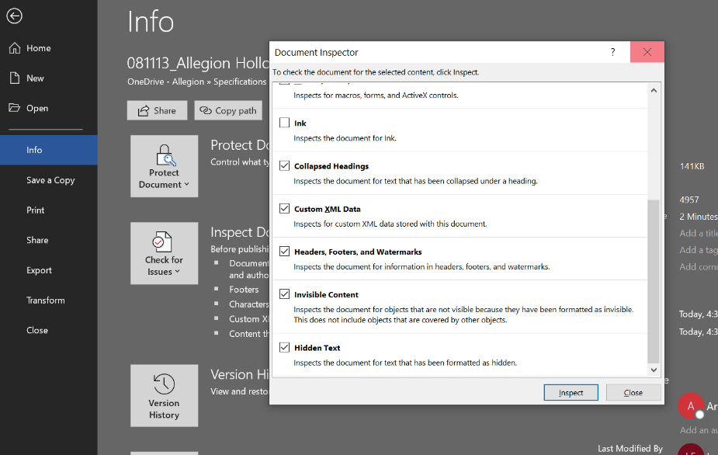All black text in this document typically will not require editing (except where the ORANGE hidden text has instructions to make a selection)
2. We have included some content in blue text, which indicates the atypical choice, or an option that will likely need to be deleted from this document.
3. If you “**print**” your document, either on paper or to a pdf – the instructional text will not appear.
4. If you are sending an electronic copy of this document to an architect, please follow the steps listed below.
   1. **Save** **As** – save your document as needed for your project.
   2. Go to **File**/**Info**/**Inspect** **Document** and when the dialog box pops up, ensure that “**hidden** **text**” is checked off
   3. 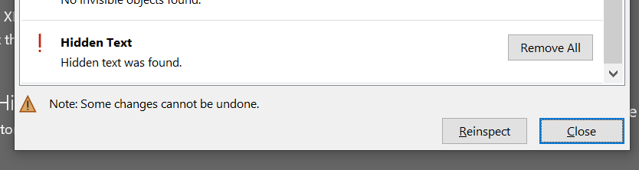Click “**Inspect**”
   4. Click on “**Remove** **All**” next to hidden text, and then close.
   5. All hidden instructional text will be removed.
   6. On the Home tab click **Select**/**Select** **All** and then choose “**black**” as the text color to convert any remaining blue text to black.

SECTION 08 34 90

TORNADO-RESISTANT ASSEMBLIES

see instructional notes throughout this document. ORANGE is hidden text so will not print. To view without hidden text go to File>Options>Display>check off hidden text.

1. GENERAL
   1. RELATED DOCUMENTS
      1. Drawings and general provisions of the Contract, including General and Supplementary Conditions and Division 01 Specification Sections, apply to this Section.
   2. SUMMARY
      1. Section includes:
         1. Hollow metal Tornado Doors
         2. Hollow metal Doors with Glass Lights
         3. Hollow metal Tornado Frames
         4. Hollow metal Tornado Shutters
      2. Exclusions: Metal for the following is not provided under the scope of this section:
         1. Structural steel
         2. Headers and lintels
         3. Framing
         4. Steel channel frames
         5. Access panels
         6. Door hardware
      3. Related Sections:
         1. Division 01 Section “Alternates” for alternates affecting the work of this section.
         2. Division 03 Section “Precast Structural Concrete”
         3. Division 04 Section “Unit Masonry”
         4. Division 07 Section “Joint Sealants”
         5. Division 08 Section “Steel Doors and Frames”
         6. Division 08 Section “Door Hardware”
         7. Division 08 Section “Glass and Glazing”
         8. Division 09 Sections for touchup finishing or refinishing of existing openings modified by the work of this section.
         9. Division 26 Sections for connections to electrical power system and for low-voltage wiring work.
         10. Division 28 Sections for coordination with other components of other components of electronic access control system.
   3. REFERENCES

*NOTE: Add/edit as necessary.*

* + 1. Tornado Resistant Assemblies
       1. IBC – International Building Code
          1. 2021 Edition, Section 423 – Building types or functions and geographic locations to be built with a storm shelter.
       2. ICC/NSSA - International Code Council / National Storm Shelter Association
          1. ICC 500-2020 Standard for the Design and Construction of Storm Shelters
       3. FEMA – Federal Emergency Management Agency
          1. FEMA P-361, Fourth Edition / April 2021 – Safe Rooms for Tornados and Hurricanes: Guidance for Community and Residential Safe Rooms
          2. FEMA P-320, Fifth Edition / March 2021 – Taking Shelter from the Storm: Building a Safe Room for Your Home or Small Business
    2. Fire/Life Safety
       1. NFPA - National Fire Protection Association
          1. NFPA 70 – National Electric Code
          2. NFPA 80 - Standard for Fire Doors and Fire Windows
          3. NFPA 101 - Life Safety Code
          4. NFPA 105 - Smoke and Draft Control Door Assemblies
       2. State Fire Safety Code.
    3. UL - Underwriters Laboratories
       1. UL 10C - Positive Pressure Test of Fire Door Assemblies
       2. UL 1784 - Air Leakage Tests of Door Assemblies
    4. Accessibility
       1. ADA - Americans with Disabilities Act.
       2. ANSI A117.1 - Accessible and Usable Buildings and Facilities.
    5. SDI – Steel Door Institute
       1. SDI 100/ANSI A250.8 - Recommended Specifications - Standard Steel Doors and Frames.
          1. SDI Certified https://www.steeldoor.org/sdicertified.php
       2. SDI 105 - Recommended Erection Instructions for Steel frames.
       3. SDI 111 - Recommended Details and Guidelines for Standard Steel Doors and Frames and Accessories.
       4. SDI 112 - Zinc-Coated (Galvanized/Galvannealed) Standard Steel Doors and Frames.
       5. SDI 117 - Manufacturing Tolerances for Standard Steel Doors and Frames.
       6. SDI 118 - Basic Fire Door Requirements.
       7. SDI 122 - Installation and Troubleshooting Guide for Standard Steel Doors and Frames.
       8. SDI 124 - Maintenance of Standard Steel Doors and Frames.
    6. ANSI - American National Standards Institute (refers to most current versions of standards)
       1. ANSI/DHI A115.IG - Installation Guide for Doors and Hardware.
       2. ANSI/BHMA A156.1 - A156.29, and ANSI A156.31 - Standards for Hardware and Specialties
       3. ANSI A250.3 - Test Procedure and Acceptance Criteria for - Factory Applied Finish Painted Steel Surfaces for Steel Doors and Frames.
       4. ANSI A250.4 - Test Procedure and Acceptance Criteria for - Physical Endurance for Steel Doors, Frames, Frame Anchors, and Hardware Reinforcings. Product is tested and provided as Level “A”, 1,000,000 cycle test criteria and other requirements as listed in these specifications.
       5. ANSI A250.6 - Recommended Practice for Hardware Reinforcing on Standard Steel Doors and Frames.
       6. ANSI/SDI A250.8/SDI-100 Recommended Specifications for Standard Steel Doors and Frames.
       7. ANSI A250.10 - Test Procedures and Acceptance Criteria for – Prime Painted Steel Surfaces for Steel Doors and Frames.
       8. ANSI A250.11 - Recommended Erection Instructions for Steel Frames.
    7. NAAMM - National Association of Architectural Metal Manufacturers
       1. NAAMM/HMMA-840 - Guide Specification for Installation and Storage of Hollow Metal Doors and Frames.
  1. SUBMITTALS
     1. General:
        1. Submit the following in accordance with conditions of contract and Division 01 requirements.
        2. Advise Architect within the submittal package of incompatibility or issues which may detrimentally affect the work of this section.
        3. Prior to forwarding submittal: Comply with procedures for verifying existing door and frame compatibility for new hardware, as specified in PART 3, “EXAMINATION” article, herein.
     2. Action Submittals:
        1. Product Data: Provide illustrations from manufacturer’s catalogs and data in brochure form for all products, including model, function, reinforcements, anchoring, design, finish, and options.
        2. Door and Hardware Schedule: Organize schedule into spreadsheet format indicating complete designations of every item required for each door and frame. Door and hardware schedule shall clearly indicate architect's door number, elevations, and notes.
        3. Shop Drawings: Drawings of openings aligning with the Door, frame, and hardware schedule in accordance with SDI 111D. Show types, quantities, dimensions, specified performance, design criteria, materials and similar data for each opening required.
           1. Indicate frame configuration, anchor types and spacing, location of cutouts for hardware, reinforcement, to ensure doors and frames are properly prepared and coordinated to receive specified hardware.
           2. Indicate all door elevations, internal reinforcements and closure methods.
           3. Indicate all hardware and accessories.
        4. Templates: After final approval of the door and hardware schedule, provide listing of manufacturer's hardware locations for each item of hardware.
     3. Informational Submittals:
        1. Qualification Data: For manufacturer, supplier, installer and Certified Door Consultant.
           1. Supplier: A direct account of the manufacturer who has on permanent staff, an Architectural Hardware Consultant (AHC), a Certified Door Consultant (CDC) or an Architectural Openings Consultant (AOC), who will be available to consult with the Architect and Contractor regarding matters affecting the door and frame openings.
        2. Product Certificates and Test Reports: For compliance with accessibility requirements, based on evaluation of comprehensive tests performed by the manufacturer and witnessed by a qualified, accredited testing agency for doors and frames located in accessible routes.
           1. Evidence of manufacturer as “SDI Certified” from the Steel Door Institute.
           2. Manufacturer evidence of compliance with standards shown in 1.03 “References” section of this document.
           3. Listing Report number from an accredited testing and labeling facility (Intertek / UL) for the AHJ’s reference to the tornado approval. Listing Report shall communicate design wind pressure and missile impact tests in accordance with FEMA 361 / ICC 500-2020 requirements.
           4. Report with calculations of anchoring requirements including locations and minimum required capacity from a third-party PE based on accepted engineering practice shall be made available upon request.
           5. Certificate or signed letter stating 5 years minimum experience installing labeled tornado products.
           6. Certificates of compliance and installation instructions shall be made available upon request of Architect or authority having jurisdiction.
        3. Warranty: As specified in this section pertaining to manufacturer, supplier and installer.
     4. OPTION: LEED Submittal
        1. Where this project is to be registered with the US Green Buildings Council and certified under the LEED 2009 Green Buildings Program, the following shall apply;
        2. Credit MR 4 - Recycle Content: Provide manufacturer’s certification as a percentage by weight for pre-consumer and post-consumer recycled material for all doors and frames on the project. The recycled percentage of the product shall be calculated against the final cost of the product to determine the recycled content dollar value.
     5. Closeout Submittals:
        1. Operations and Maintenance Data: Provide in accordance with Division 01 and include the following:
           1. Complete information on care, maintenance, and adjustment; data on repair and replacement.
           2. Catalog pages for each product.
           3. Name, address, and phone number of local representative for each manufacturer.
           4. Copy of final approved door and frame schedule, edited to reflect conditions as-installed.
           5. Copy of warranties including appropriate reference numbers for manufacturers to identify the project.
  2. QUALITY ASSURANCE
     1. Product Substitutions: For the purpose of performing the work of this section, comply with product requirements stated in Division 01 and as specified herein.
        1. Where a specific manufacturer’s product is named and accompanied by the words “No Substitute,” including make or model number or other designation, provide the product exactly as specified. (Note: Certain products have been selected for their unique characteristics and particular project suitability.)
           1. Where no additional products or manufacturers are listed in a product category, requirements for “No Substitute” govern product selection.
        2. Where products indicate “acceptable substitute” or “acceptable manufacturer”, provide product from specified manufacturers, subject to compliance with specified requirements and “Single Source Responsibility” requirements stated herein.
        3. Substitutions: Refer to Division 01 for additional information regarding substitutions and submittals.
     2. Supplier Qualifications and Responsibilities: A direct account of the manufacturer. A recognized hollow metal door and frame supplier of tornado-resistant approved systems, with warehousing facilities in the project's vicinity, that has a record of successful in-service performance for supplying hollow metal doors and frames similar in quantity, type, and quality to that indicated for this project.
        1. Engineering Responsibility: Preparation of data for field spliced or field modified units, including shop drawings, based on testing and engineering analysis of manufacturer's standard units in assemblies similar to those indicated for this project.
        2. Coordination Responsibility: Coordinate preparation of the door hardware and provide installation and technical data to the Architect and other related subcontractors.
           1. Upon completion of hollow metal door and frame installation, inspect and verify that all components are working properly.
     3. Manufacturer: Member of Steel Door Institute and is SDI Certified, with specialized capabilities manufacturing tornado-resistant opening systems complying with ICC 500-2020 and FEMA 361, and provides labeled doors and frames from a qualified, accredited testing agency, including hardware and accessories as specified in this section with minimum five years documented experience manufacturing tornado labeled systems.
        1. Manufacturer Installation Instructions: Contractor shall maintain a current copy of tornado shelter storm door, frame and hardware manufacturer published installation instructions and FEMA 361/ICC 500-2020 requirements in Project Field Office and refer to installation instructions at all times during installation.
        2. Tornado-Resistant Openings Systems: Provide complete door systems for tornado-resistant storm shelters and other areas of refuge complying and tested according to FEMA 361, Fourth Edition / April 2021, Design and Construction Guidance for Community Safe Rooms; and ICC 500 (2020), ICC/NSSA Standard for the Design and Construction of Storm Shelters.
        3. Label tornado-resistant doors and frames with permanently affixed metal labels (non-Mylar) to clearly denote compliance with FEMA 361 and ICC 500-2020.
           1. Each door and frame will have its own permanent label showing what criteria the door and frame was tested in accordance with. The label will show what independent laboratory tested this assembly. The label will show test pressures both positive and negative in pounds per square foot and the design pressure both positive and negative.
           2. Doors with glass shall be etched or similarly labeled.
     4. Installer Qualifications: Qualified tradesmen, skilled in the application of tornado hollow metal doors and frames that has a record of successful in-service performance for installing hollow metal doors and frames similar in quantity, type, and quality to that indicated for this project.
     5. Single Source Responsibility: Obtain each type of hollow metal door and frame from a single manufacturer.
     6. Fire-Rated Openings: Provide doors and frames for fire-rated openings that complies with NFPA Standard No. 80, UL10C, Category “A”, Positive Pressure Test of Fire Door Assemblies, and requirements of authorities having jurisdiction. Provide only doors and frames that are labeled and listed for ratings indicated by Underwriters Laboratories, Intertek Testing Services, or other testing and inspecting organizations acceptable to the authority having jurisdiction.
        1. Affix a physical label or approved marking to each fire door or fire door frame, at an authorized facility as evidence of compliance with procedures of the labeling agency. Label embossment is not permitted.
        2. Conform to applicable codes for fire ratings. It is the intent of this specification that hardware and its application comply or exceed the standards for labeled openings. In case of conflict between types required for fire protection, furnish type required by NFPA and UL.
        3. Fire door assemblies in exit enclosures and exit passageways; maximum transmitted temperature end point rating of not more than 250 degrees F (121 degrees C) above ambient at the end of 30 minutes of the standard fire test exposure.
     7. Refer to Division 01 Section “Special Conditions” for additional information and minimum experience requirements.
  3. DELIVERY, STORAGE, AND HANDLING
     1. Tag each item or package separately with identification related to the final door and frame schedule, and include installation instructions with each delivery.
     2. Comply with manufacturer’s current written instructions and recommendations.
     3. Deliver doors in manufacturer’s standard labeled protective packaging.
     4. Accept products on site in manufacturer’s packaging. Inspect for damage. Return damaged Products and replace with undamaged products.
     5. Project field superintendent shall inspect products immediately upon delivery to project site, determine Product conformance with specified requirements and reject Products not complying with specifications. Project field superintendent shall direct that non-complying products be removed from project site immediately.
     6. Handle, store and protect products in accordance with the manufacturers printed instructions and ANSI/SDI A250.10 and NAAMM/HMMA 840.
     7. Project Conditions:
        1. Maintain manufacturer-recommended environmental conditions throughout storage and installation periods.
     8. Protection and Damage:
        1. Promptly replace products damaged during shipping with exactly the same products.
        2. Handle doors and frames in manner to avoid damage, marring, or scratching. Correct, replace or repair products damaged during the course of the Work.
        3. Protect products against malfunction due to paint, solvent, cleanser, or any chemical agent.
     9. Refer to Division 01 Sections “Summary of Work” and “Special Conditions” for additional information and requirements regarding stored materials.
  4. COORDINATION
     1. Coordinate layout and installation of floor-recessed door hardware with floor construction. Cast anchoring inserts into concrete. See Division 03 for concrete, reinforcement, and formwork requirements, and Division 04 2000 “Unit Masonry”.
     2. Coordinate work with frame opening construction, door and hardware installation. Coordinate work with Section 08 11 00 Steel Doors and Frames, Section 08 71 00 Finish Hardware, and other directly affected sections involving manufacture or fabrication of internal cutouts and reinforcement for door hardware, electric devices and recessed items.
     3. Verify field dimensions for factory assembled frames prior to fabrication.
     4. Installation: Sequence installation to accommodate required door hardware. Check shop drawings of other work to confirm that adequate provisions are made for locating and installing doors and frames to comply with indicated requirements.
     5. Electrical System Roughing-In: Coordinate layout and installation of doors and frames with electrified door hardware connections.
  5. WARRANTY
     1. Provide manufacturer's warranties as specified in Division 01 and as follows:
        1. Hollow Metal Doors and Frames: 1 year.
        2. Warranty does not cover damage or faulty operation due to improper installation, improper use, or abuse.
  6. MAINTENANCE
     1. Maintenance Instructions: Furnish a complete set of maintenance instructions as needed for Owner's continued maintenance of doors and frames.

1. PRODUCTS
   1. MANUFACTURERS
      1. Approval of manufacturers and/or products other than those listed as “Scheduled Manufacturer” or “Acceptable Manufacturers” in the individual article for the product category shall be in accordance with QUALITY ASSURANCE article, herein.
      2. Acceptable Manufacturer: Allegion System assemblies including Steelcraft, Paladin Series PW doors and FP frames, latching hardware from Von Duprin Exit devices, Schlage LM9300 Multipoint locks and Ives surface bolts, and approved Allegion hardware accessories
   2. OPTION*:* EXISTING MATERIALS
      1. Where existing doors and/or frames are indicated to be removed and reinstalled:
         1. Carefully remove doors, frames, and/or components.
         2. Clean, protect and store existing doors and/or frames in accordance with storage and handling requirements specified herein.
         3. Reinstall in accordance with installation requirements for new doors and/or frames.
      2. Existing openings must follow the same FEMA 361 guidelines and ICC 500-2020 standards as described in this tornado specification. The contractor is responsible for compliance of the wall system to be sure that the opening will accept approved Intertek or UL labeled tornado doors and frames. Signed/Sealed Third party certified PE drawings, calculations and/or site-specific inspections may be required by the Authority Having Jurisdiction (AHJ) to ensure proper wall and floor construction and anchoring for the tornado system labeled approval.
      3. When modifying existing fire-rated openings, provide materials permitted by NFPA 80 and UL 10C as required to maintain fire-rating.
   3. MATERIALS
      1. Fasteners
         1. Provide fastenings, anchors and clips as required to secure hollow metal work in place. Provide manufacturers standard screws. Dimple metal work to receive screw heads. Set stops and other non-structural fastenings with manufacturer’s standard self-tapping screws.
      2. OPTION if existing doors, otherwise delete this paragraph: Modification and Preparation of Existing Doors and/or Frames: Provide necessary fillers, reinforcements, and fasteners, compatible with existing materials, as required for mounting new opening hardware and to cover existing door and frame preparations.
         1. When possible, use materials which match materials of adjacent modified areas.
         2. When modifying existing fire-rated openings, provide materials permitted by NFPA 80 as required to maintain fire-rating.
   4. Steel Frames – Paladin FP14 Series Frames
      1. Manufacturer:
         1. Scheduled Manufacturer: Steelcraft.
         2. Acceptable Substitute: (list compliant and tornado assembly tested competitor, if exists).
      2. Provide 14 Gauge A60 galvannealed steel.
      3. Provide tornado-resistant hollow metal frames as scheduled, and drawn and detailed on plans, with the provisions below.
      4. Provided die-mitered corner connections to ensure tight/closed miters at head and jambs.

Select **KD** or **Welded** below. Remove the other option from the specification.

* + 1. Factory prep: Welded
    2. Factory prep: KD, frames welded by distributor.
    3. Provide patented universal hinge preparations.
    4. Provide beveled hinge and strike edges.
    5. Provide 7 gauge hinge reinforcement. Where continuous hinges are provided in 08 71 00, provide 14 gauge full length reinforcement for continuous hinges.
    6. Provide 12 gauge steel center strike reinforcement with 14 gauge head/sill strike reinforcement. Option: with 12 gauge head/sill strike reinforcement, update if required.
    7. Provide adjustable base anchors to allow for adjustment in installation when the floor is not level.
    8. Provide factory applied baked-on rust-inhibiting primer.
    9. Frames shall be installed with or without out grout fill. When using 4” face, provide frames grouted full utilizing proper grout fill protocols per SDI/ANSI 250.8. Grouting procedures shall follow hollow metal installation instructions and common practice.
    10. Provide 14 gauge steel closer reinforcements when specified.
    11. Opening sizes: Shall not exceed the smallest and largest sizes tested and approved per ICC 500-2020. Available sizes shall be publicly available on Intertek or UL listing websites.
    12. Fire Rating: Where called for by the door and hardware schedules, tornado-resistant doors, frames, shutter, and glass lights shall be identified by an official metal label or etching (for glass) to signify tested approval from ITS – Warnock Hersey or Underwriters' Laboratories, to UL 10C protocols.
  1. Steel Frames – Paladin FP14 Shutter Systems
     1. Provide hollow metal frames as scheduled, and drawn and detailed on plans, with the provisions below.
     2. Glass: Non-impact resistant glass (provided by others) can be installed in exterior (storm side) rabbet of frame.
     3. Instructions for the installation or deployment of shutters shall be made available from the manufacturer.
  2. Steel Frames – Anchoring
     1. Provide hollow metal frames as scheduled, and drawn and detailed on plans, with the provisions below.
     2. Approved frame anchors and any necessary anchor bolts certified by third party PE reports shall be provided from the factory for concrete walls (tilt-up/pre-fab/poured in place) or concrete-filled CMU block walls.
     3. Provide installation instructions.
     4. Provide anchoring approved by UL or Intertek Testing Services / Warnock Hershey (ITS/WHI), supported by testing and third-party PE reports. Approved anchoring shall provide a structural connection from the approved shelter foundation to shelter walls.
     5. Grout new masonry frames full.
     6. Provide frames to be used in existing masonry with tube and strap anchors welded from the factory.
  3. Steel Doors – Paladin PW14 Series Doors
     1. Provide tornado-resistant hollow metal doors as scheduled, and drawn and detailed on plans, with the provisions below.
     2. Provide standard 14 gauge, A-60 galvannealed steel face skins for resistance against corrosion.
     3. Steel stiffened core construction: Provide stiffeners welded or bonded to both face sheets.
     4. Seamless, full height, mechanical interlock edges: Provide lock and hinge edges intermittently welded and filled smooth for structural support and stability the full height of the door
     5. Provide full height lock side continuous minimum 12 gage steel reinforcement channels at lock rails.
     6. Provide 12 gauge top channel and 14 gauge bottom channel steel reinforcement.
     7. Provide doors with beveled hinge and lock edges.
     8. Provide universal hinge preparations.
     9. Provide 7 gauge hinge reinforcements.
     10. Provide 14 gauge closer reinforcements.
     11. Provide factory applied baked-on rust-inhibiting primer in accordance with ANSI A250-10, with finish paint options available.
     12. Provide 1-3/4 inch thick doors.
     13. Opening sizes shall not exceed the smallest and largest sizes tested and approved per ICC 500-2020. Available sizes shall be publicly available on Intertek or UL listing websites.
     14. Provide handed doors and frames.
     15. Provide doors beveled both hinge and lock sides.
     16. Custom door undercuts shall be made available, provided they meet with the labelling agencies requirements.
     17. Follow installation instructions provided by the manufacturer. The hardware manufacturer’s strike must be used. Anchor or grout bottom strikes into the foundation slab.
  4. tornado Glass lights, labeled and non-labeled glazing
     1. Provide approved tornado trim and glazing pre-installed from the factory.
     2. Provide installation and care instructions to maintain tornado ratings.
     3. Provide glass with an etching to signify compliance from ITS – Warnock Hersey or Underwriters' Laboratories. Embossed labels are not acceptable.
     4. For fire rated assemblies with glass, a UL classified fire rated sealant must be used.
  5. FINISHES
     1. Chemical Treatment: Treat steel surfaces to promote proper paint adhesion per ANSI/SDI A250.3, Test Procedure and Acceptance Criteria for Factory Applied Finished Painted Steel Surfaces for Steel Doors and Frames.
     2. Factory Prime Finish: Meet requirements of ANSI A 250.10., Test Procedure and Acceptance Criteria for Prime Painted Steel Surfaces for Steel Doors and Frames.
  6. tornado-resistant Door Hardware AND ACCESSORIES
     1. Provide approved hardware and accessories under Section 08 71 00 as part of the complete prescriptive door system approved by the Intertek or UL public listing for the labeled tornado-resistant assembly, communicating compliance with FEMA 361 guidelines and ICC 500-2020 standards.
     2. Per ICC 500-2020 Section 507 requirements, operating hardware on the non-egress side shall be locked, disabled, or inactive and shall not be susceptible to unintentional unlatching by debris impact. If unlocked, non-egress hardware must be lockable from the protected side of the door with clear indicators and/or signage to instruct occupants to lock and clearly post how to lock down in an approaching storm event.
  7. FABRICATION
     1. Fabricate doors and frames in accordance with requirements of ANSI A250.8-2003/SDI 100.
     2. Fabricate fire rated doors and frames in accordance with requirements of ITS – Warnock Hersey or Underwriters' Laboratories, with metal label on each door and frame signifying UL-10C compliance.
     3. Typical Frame Reinforcing: Provide steel reinforcement as required for hardware items per manufacturers templates. Provide reinforcing per ANSI-A250.6.
     4. Mortar Guards in Frames: For hinge and strike plate cutouts, provide fully enclosed pressed steel cover boxes spot welded to frames behind mortises. Additionally, for frames in masonry walls and frames being grout filled, provide metal mortar guards for any mortised cutouts.
     5. Hardware Preparation at Frames: Mortise, reinforce, drill and tap as required for all mortised hardware furnished under Division 8 Finish Hardware and/or Division 26 Security in accordance with a final approved hardware schedule and templates provided by the hardware supplier and/or security supplier (including electric hinges and/or power transfers, door position switches, and other electrified hardware). Drilling and tapping for surface door closers, door closer brackets, and adjusters shall be done in field by hardware installer. Obtain templates from hardware and security suppliers. Provide hardware preparation per ANSI-A250.6.
     6. Joining at Frames:

Select **KD** or **Welded** below. Remove the other option from the specification.

* + - 1. **Knock Down (KD) Frames:**  At interior and exterior three-sided door frames and 4-sided shutter frames, in masonry type walls, use knock down (KD) masonry type to be installed while wall is being constructed.
      2. **Welded Frames:**  At welded frames with equal width jambs and head, neatly miter on face and cope and butt stops. At other welded frames, provide same mitered joint wherever possible (at intersection of jamb-head or jamb-sill) and at other locations butt metal neat. OPTION – select Face Weld or Full Profile Weld and remove the other. Face weld, or full profile weld as specified. Fabricate so no grind marks, hollow or other out-of-plane areas are visible. At joints of intermediate members (such as mullions), provide tight joining, neatly accomplished without holes, burned out spots, weld build up or other defacing work. Fill to close cracks and to preserve shapes. Tightly fit loose stops, to hairline joints. Joints shall be finished and primed.
    1. Typical Door Reinforcement: Provide galvannealed steel reinforcement as required for hardware items per manufacturers’ templates. Provide reinforcing per ANSI-A250.6.
    2. Hardware Preparation at Doors: Mortise, reinforce, drill and tap as required for all mortised hardware furnished under Division 08 Finish Hardware and/or Division 28 Access Control in accordance with a final approved hardware schedule and templates provided by the hardware supplier and/or security supplier (including a minimum 1/2 inch raceway for electrical hardware, electric hinges and/or power transfers, door position switches, and other electrified hardware). Obtain templates from hardware and security suppliers. Provide hardware preparation per ANSI-A250.6.

1. EXECUTION
   1. EXAMINATION
      1. Prior to installation of any doors and frames, examine supporting structure and conditions under which hollow metal doors and frames are to be installed. Correct all defects prior to proceeding with installation.
      2. Correct unacceptable conditions are or defer to the architect or responsible building contractor to fix unacceptable conditions prior to hollow metal installation or at any point where unacceptable conditions are discovered.
   2. OPTION, if existing openings – if not, delete: PREPARATION
      1. Where on-site modification of doors and frames is required, prepare hardware locations in accordance with the following:
         1. Tornado assemblies shall not be unduly modified. Consult with the manufacturer or the Authority Having Jurisdiction as needed to maintain the labeled approval of the tornado door system, complying with ICC 500-2020.
         2. Steel Doors and Frames: For surface applied door hardware, drill and tap doors and frames according to ANSI/SDI A250.6.
         3. Where doors are in rated assemblies, comply with NFPA 80 for restrictions on on-site door hardware preparation.
         4. Where on-site modification of existing doors and frames is required:
            1. Remove existing hardware being replaced, tag, and store according to contract documents.
            2. Field modify and prepare existing door and/or frame for new hardware being installed.
            3. When modifications are exposed to view, use concealed fasteners, when possible.
   3. INSTALLATION
      1. Install hollow metal in accordance with reviewed shop drawings and manufacturer's printed installation and anchoring instructions supporting ICC 500-2020 tornado approvals. Securely fasten and anchor work in place without twists, warps, bulges or other unsatisfactory or defacing workmanship. Set hollow metal plumb, level, square to proper elevations, true to line and eye. Set clips and other anchors with Ramset "shot" anchors or drill in anchors as approved. Units and trim shall be fastened tightly together, with neat, uniform and tight joints.
      2. Placing Frames: Remove manufacturer’s shipping spreader-bars by grinding to avoid possible damage from hammering prior to installation. These shall not be used for setting of proper frame tolerances. Set frames accurately in position, plumbed, aligned, and braced securely until permanent anchors are set in accordance with ANSI A250.11. After wall construction is complete, remove temporary braces and/or installation spreaders leaving surfaces smooth and undamaged. In masonry construction, building-in of anchors and grouting of frames with mortar is specified in Division 04 Section - Unit Masonry. At in-place concrete or masonry construction, set frames and secure in place using countersunk bolts and expansion shields, with bolt heads neatly filled with metallic putty, ground smooth and primed.
      3. Place fire-rated frames in accordance with NFPA 80, and/or manufacturer’s follow-up procedure requirements.
      4. Consult Hollow Metal technical data, installation instructions and anchoring instructions. The hardware manufacturer’s installation instructions must be followed to maintain tornado-resistant assembly approval.
      5. Where continuous hinges are specified, provide full height 3/8 inch (9.5 mm) to 1-1/2 inch (38 mm) thick strip of polystyrene foam blocking at frames requiring grouting. Apply the strip to the back of the frame, where the hinge is to be installed, to facilitate field drilling or tapping.
      6. Doors with internal concealed rods and associated latches shall be installed at the factory by the door manufacturer prior to shipment to the job site. Base installation upon FEMA lock manufacturer’s template and install instructions. Field installation, or supplier shop installation, of FEMA concealed internal rods and rod latches is only accepted with written approval from the hollow metal manufacturer.
      7. Door Installation: Fit hollow metal doors accurately in their respective frames, within following clearances: Jambs and meeting edges of pairs of beveled edge doors 3/32-1/8 inch, heads 1/8 inch, sill where no threshold or carpet 1/4 inch above finished floor, sill at threshold 3/4 inch maximum above finished floor, sill at carpet 1/4 inch above carpet. Proper gaps between door edge and strikes shall follow manufacturer’s installation instructions. Place fire-rated doors with clearances as specified in NFPA 80.
      8. Apply hardware in accordance with hardware manufacturers' instructions and Section 08 71 00 of these specifications. Install hardware with only factory-provided fasteners. Install silencers. Adjust door installation to provide uniform clearance at head and jambs, to achieve maximum operational effectiveness and appearance.
      9. Drill and tap for surface door closers, door closer brackets, and other surface applied hardware.
   4. FIELD QUALITY CONTROL
      1. After installation of frames has been completed, a qualified person from the hardware installation company is to check the project to confirm the proper installation of frames to allow for the proper installation of doors and finish hardware scheduled.
      2. Installer shall deliver to owner, upon completion, one set of installation and maintenance instructions for doors and frames.
      3. Regular field inspection and adjustment is accepted and recommended to ensure proper latching throughout the life of the product.
   5. ADJUSTING
      1. Final Adjustments: Adjust doors and hardware prior to final inspection and acceptance by the Architect and Owner. Replace defective items including doors or frames that are damaged or unacceptable to the Architect and Owner. Regular field inspection and adjustment is accepted and recommended to ensure proper latching throughout the life of the product.
         1. Adjust doors for proper operation, free from binding or other defects.
         2. Clean and restore soiled surfaces. Remove scraps and debris and leave site in a clean condition.
         3. Prime Coat / Touch up immediately after erection, sand smooth rusted or damaged areas of prime coat, and apply touch-up of compatible, approved air-drying primer
      2. Fire Door Assembly Inspection and Testing: Upon completion of the installation, provide functional testing and inspection of each fire door assembly on the project to confirm proper operation and that it meets all criteria of a fire door assembly as per NFPA 80. Inspections shall be performed by individuals who are certified by Intertek as a Fire Door Assembly Inspector (FDAI) or a credentialed Architectural Hardware Consultant (AHC). A written report using reporting forms provided by the Door and Hardware Institute shall be maintained and transmitted to the Owner and made available to the authority having jurisdiction (AHJ). The report shall list each fire door throughout the project, and include each door number, location, hardware set used and summary of deficiencies.
         1. Schedule fire door assembly inspection within 90 days of substantial completion of the project.
         2. Correct all deficiencies and schedule a re-inspection of fire door assemblies which were noted as deficient on the inspection report.
         3. Inspector shall re-inspect fire door assemblies after repairs are made.
         4. Additional re-inspections which are required due to incomplete repairs will be performed by the inspector at the expense of the Contractor.
      3. Prime Coat Touch-Up: Immediately after installation, sand smooth rusted or damaged areas of prime coat and apply touch-up of compatible air-drying primer.
   6. PROTECTION
      1. Provide for the proper protection of doors and frames until the Owner accepts the project as complete. Damaged or disfigured doors and frames shall be replaced or repaired by the responsible party. Some repairs may not be allowed in the field in order to maintain the labeled tornado approval. Consult with the manufacturer or the Authority Having Jurisdiction.
      2. Advise General Contractor on measures necessary to protect installed products and finished surfaces from damage during construction.

END OF SECTION